**Resource Pack**

This is not essential reading but supporting information for anyone wanting to know more about Surrealism, including its links to Solihull.

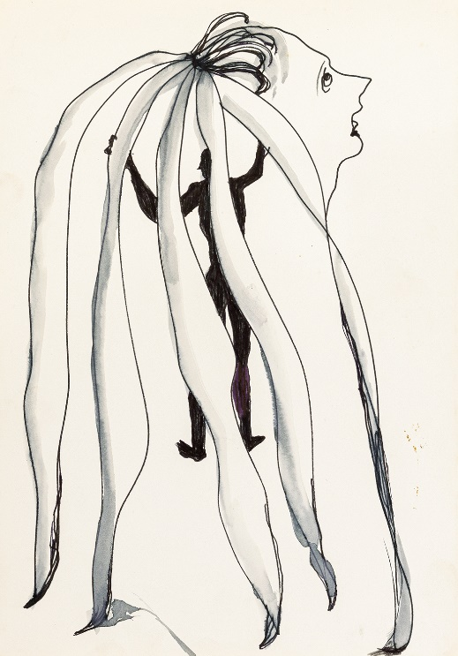 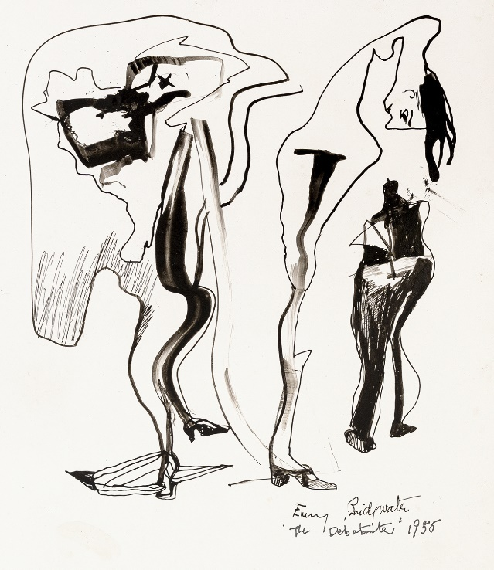

Emmy Bridgwater, ‘The Debutante’, 1955, Ink on paper and ‘Untitled’, c. 1940s, gouache on paper © The Mayor Gallery, London

**Contents:**

1. **An overview of Surrealism**
2. **Emmy Bridgwater and British Surrealism**
3. **Further reading/listening**
4. **Selection of artworks by Emmy Bridgwater**

***

1. **An overview of Surrealism**

Surrealism was a cultural and intellectual movement that flourished across Europe in the late 1910s and early 1920s. It was founded in 1924 by the poet André Breton who defined Surrealism as:

*“pure psychic automatism by which it is intended to express, either verbally or in writing, the true function of thought.”*

Surrealism reacted against the Enlightenment—the influential 18th-century intellectual movement that championed reason and individualism. Instead, Surrealism’s goal was to liberate thought, language, and human experience from the oppressive boundaries of rationalism and for artist, writers, poets and thinkers to explore the irrational, unconscious mind.

Having studied the psychoanalytical writings of Sigmund Freud, Breton was particularly interested in the idea that the unconscious mind—which produced dreams—was the source of artistic creativity; this became a key theme of many Surrealist artworks, writings and performances.

Today, 100 years after the birth of Surrealism, contemporary artists continue to take inspiration from this radical modern art movement across diverse media.

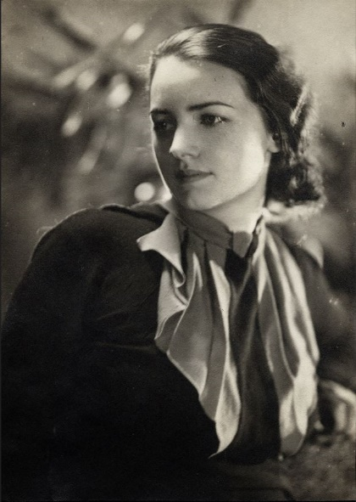

*Portrait of Emmy Bridgwater, courtesy of the artist’s estate*

1. **Emmy Bridgwater and British Surrealism**

On 11 June 1936, the International Surrealist Exhibition opened in London. Visitors were awed and baffled as Salvador Dalí delivered a lecture while wearing a full deep-sea diving suit. None was more impacted by this dramatic arrival of Surrealism in Britain than a 30-year-old artist and poet: Emma ‘Emmy’ Bridgwater.

Back in the West Midlands, she invoked the Surrealist principle of juxtaposing unusual objects to reveal uncanny narratives; in her paintings and ink drawings viewers are invited into interior worlds, defined by a symbolic language of birds, eggs and organic forms.

She experimented with automatic ink drawing as a means of accessing and expressing her subconscious, without bounds. Impressed, Breton wrote in the 1940s: “Bridgwater brought a new purity of outlook to British Surrealism, returning to the early days of the movement, to its ‘automatic’ beginnings in France”. He invented her to Paris – to sign a Surrealist manifesto and exhibit her works in a major gallery show.

But, and as has been the case for so many women artists throughout history, caring duties took precedence over Bridgwater’s career – she had to look after both her elderly mother and disabled sister throughout the 1950s and 60s.

Bridgwater did then return to the scene in the 1970s, when she primarily produced collages, and exhibited in numerous group Surrealist shows until her death in Solihull on 13 March, 1999.

To read Bridgwater’s full biography please click [here.](https://awarewomenartists.com/en/artiste/emmy-bridgwater/)

1. **Further reading/listening**

Listen to [BBC Radio 4 - The Balsall Heath Bohemians: Stewart Lee celebrates the Birmingham Surrealists](https://www.bbc.co.uk/programmes/m001p6rs)

Read [Five Birmingham artists at the heart of British Surrealism | Art UK](https://artuk.org/discover/stories/five-birmingham-artists-at-the-heart-of-british-surrealism)

Read [Emmy Bridgwater — AWARE (awarewomenartists.com)](https://awarewomenartists.com/en/artiste/emmy-bridgwater/)

1. **Selection of artworks by Emmy Bridgwater**

Emmy Bridgwater’s estate is managed by The Mayor Gallery, London. Her works can be found in public collections including: Birmingham Museum and Art Gallery, RBSA Gallery and The British Museum.

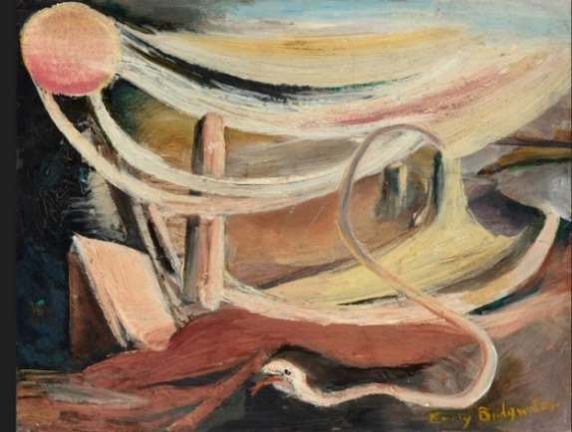

*Emmy Bridgwater, ‘The Unpredictable’, c.1942, Oil on board*

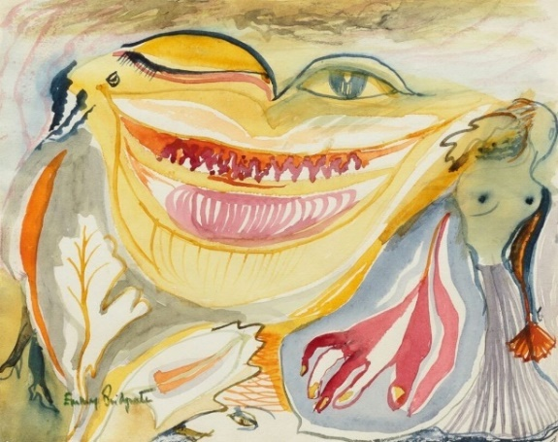

*Emmy Bridgwater, ‘Untitled (smile)’, c.1942, Watercolour*

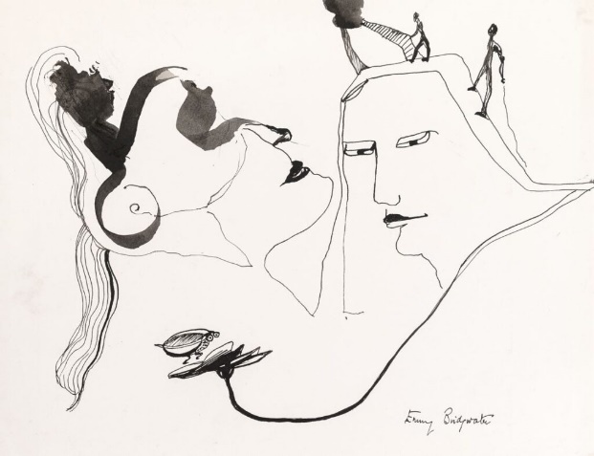

*Emmy Bridgwater, ‘Untitled’, c. 1947, Ink on paper. Royal Birmingham Society of Artists Permanent Collection.*

*Emmy Bridgwater, ‘Stark Encounter’, c.1940, Ink on paper. Royal Birmingham Society of Artists’ Permanent Collection.*

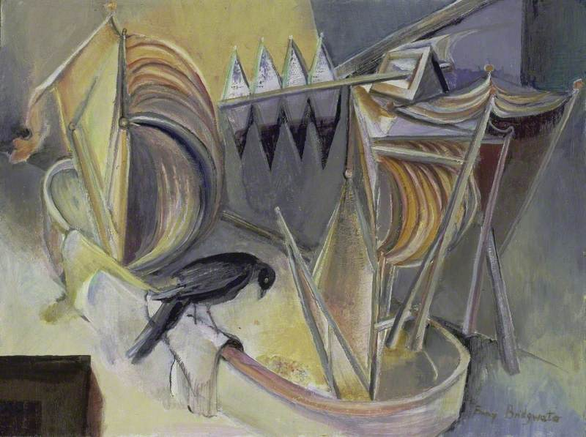

*Emmy Bridgwater, ‘Nightwork is about to commence’, 1940-3. Birmingham Museums Trust.*